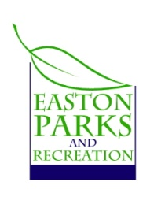
5th Annual
Trunk or Treat
Sponsored by: Girl Scouts, Easton Lions Club & Easton Park & Rec
Come help re-create the Easton Neighborhood & enjoy this SWEET Event!
When and Where?
October 31st
5:00pm Trunk Set-up
6:30 - 7:30 PM Trick-or-Treating
7:00 PM Bonfire and Costume Contest
7:45 PM “Brotherhood Knights of Gore” Show
8:30 PM Photos
Bounce House, Photo Booth, Inflatable Corn Maze, Trick or Treating, Bonfire and Show!
Cost is FREE
(Candy donations gratefully accepted at Park & Rec!)
What is Trunk or Treat?
Adults, senior, groups decorate cars and hand out treats from their trunks. Children go from car to car collecting candy while enjoying your creativity.
How do I decorate my trunk?
Anyway you like - themes such as sports, teams, travel locations, animals or general Halloween decorations. Please nothing too scary or gruesome.
What if I want to decorate my trunk and take my kids trick or treating?
Girl Scouts will be available to hand out candy for you or take your little ones around.
What is the Show?
“Brotherhood Knights of Gore” is a show of live medieval combat with a story line, as well as a kids’ area for boffer (foam weapon) fighting with the Knights.”

Children:
Trunk or Treating starts at 6:30 PM at Morehouse Fields. So be dressed and have your candy bag ready! Please ask your children to only trick or treat once. Park your car at SSES and walk over to the fields for all the fun!
Participating Cars:
Please be at Morehouse Fields by 5:00 PM. We must have all cars parked and setting up to avoid children being around moving vehicles.
Bring lots of candy to hand out!
Contact eastontrunkortreat@gmail.com to sign up your “trunk”.
Prize for the Best Trunk!

